|  |  |  |  |  |
| --- | --- | --- | --- | --- |
| Class |  | International |  | ACC |
|  |  |  |  |  |
| Name | 1 | Pratama Aji Nur Rahman | D400154003 |
|  | 2 | Amnaduny Akhara | D400154006 |
|  | 3 | Milzam Wafi Azhar | D400154007 |  |
|  | 4 | Jeski Saputra | D400154009 |  |

FINAL PROJECT

AUTOMATIC OBSTACLE AVOIDANCE CAR

1. PURPOSE
2. To reduce accident of car with sensor ultrasonic side of car to avoid obstacle.
3. TOOLS AND EQUIPMENT
4. Laptop
5. PCB (Project Board)
6. Arduino Uno
7. DC Motor
8. Sensor Ultrasonic
9. Jumper Cable
10. RESULT OF PROJECT

C.1 Circuit Design

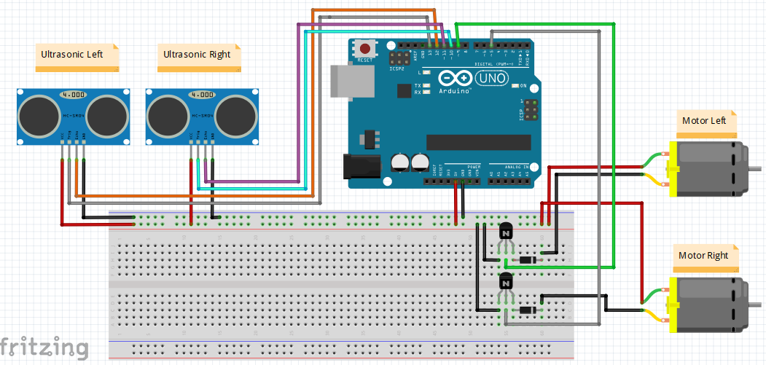

C.2 Picture of Design

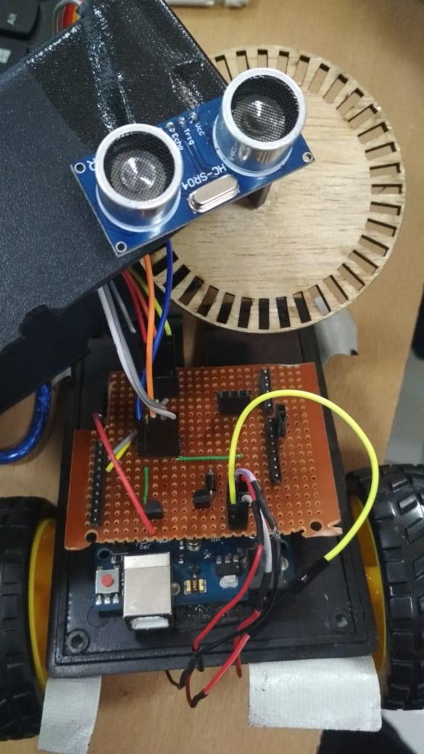

C.3 Script Program

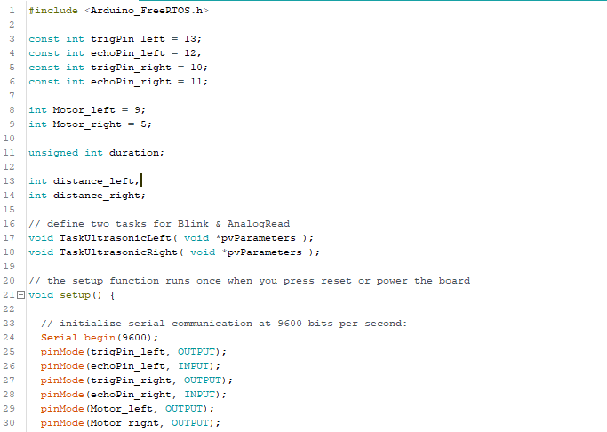

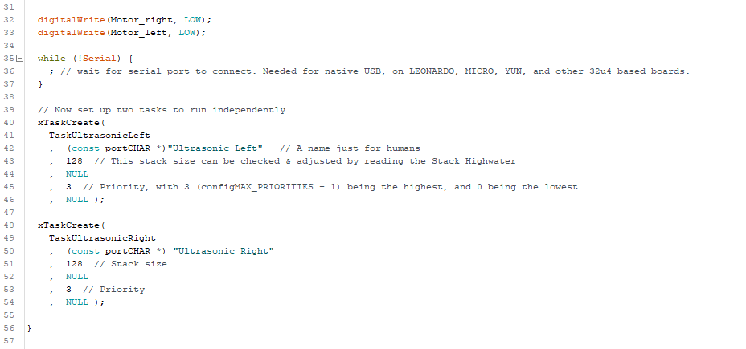

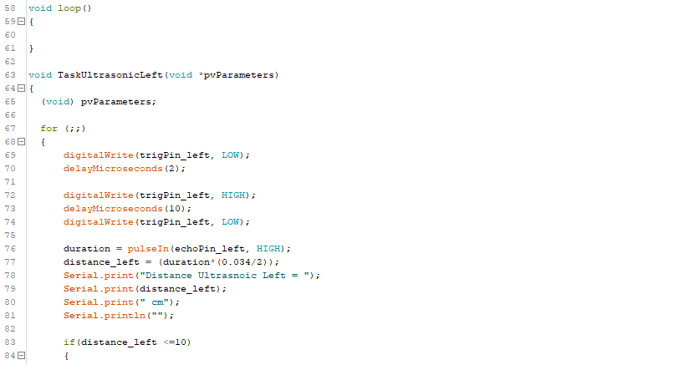

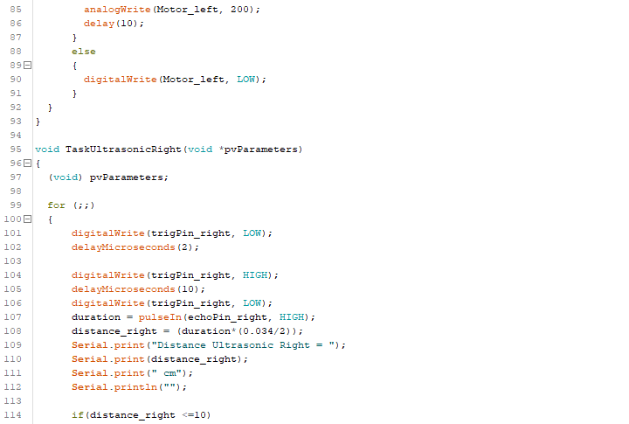

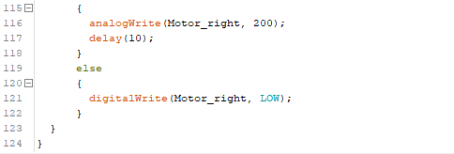

C.4 Picture of Result

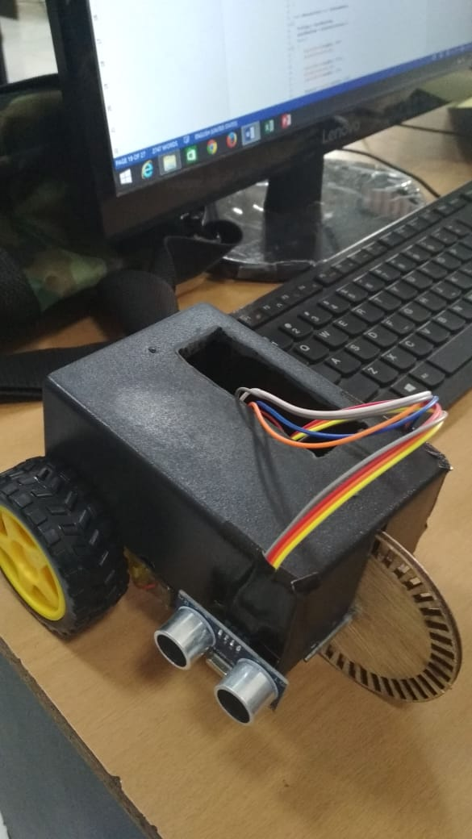

1. ANALYSIS

This machine work by giving avoidance in front of each sensor with distance <= 10 cm then the sensor will active and activated the actuators. If sensor left is active the actuator left (motor left) will active. If sensor right is active the actuator right (motor right) will active.

The script of the program is using xTaskCreate because this project is based on priority of command or program. Using xTaskCreate 2 for each sensor and each actuator. Left sensor is in left actuator. And for right sensor is in right actuator as well.

Sometimes the actuator is moving itself because of the sensor is not so precision to get distance. The actuator is like getting glitch if both of sensor is not detecting obstacle.

1. CONCLUSION
2. Each sensor and each actuator is in same task to get good connection.
3. Sensor ultrasonic is good way to avoid obstacle for car.